Univariate Analysis
Of the 10 signals analyzed via iterative monthly cross-sectional regressions of returns, momentum, earnings surprise, and SUE have the strongest positive relationships with returns over time. These factors also are the factors with the highest positive percentage of beta coefficients over the 60-month period. Insider selling and volatility, on the other hand, have the strongest average negative relationships with returns over time, also possessing the lowest positive fraction of beta coefficients over the same period. Overall, insider selling has the strongest relationship with returns and the average R² for its coefficient is more than double the next highest R² of any other factor’s beta, indicating the explanatory power of insider selling to predict returns.
Table 1 Average Monthly Univariate Coefficients.
Factor | Average Beta | T-Statistic | Average R² | Average Number of Observations
Momentum | 0.0157 | 7.0353 | 0.0447 | 200
Earnings Surprise | 0.0155 | 9.8548 | 0.0195 | 200
SUE | 0.0138 | 7.6186 | 0.0210 | 200
Accruals | 0.0077 | 3.8267 | 0.0116 | 200
Gross Profitability | 0.0042 | 2.7054 | 0.0071 | 200
Book-To-Market | 0.0033 | 2.2794 | 0.0055 | 200
F-Score | 0.0029 | 1.5718 | 0.0089 | 200
External Financing | -0.0084 | -4.5547 | 0.0121 | 200
Volatility | -0.0143 | -6.2233 | 0.0240 | 200
Insider Selling | -0.0274 | -7.3429 | 0.1000 | 200

Table 2 Positive Fraction of Monthly Univariate Coefficients.
Factor | Positive Fraction of Coefficients
Momentum | 0.9000
Earnings Surprise | 0.8333
SUE | 0.8000
Accruals | 0.7167
F-Score | 0.6833
Gross Profitability | 0.6667
Book-To-Market | 0.6500
External Financing | 0.2667
Volatility | 0.2667
Insider Selling | 0.2167

There is variability in the estimates for all coefficients over time, but the mean for all factors but insider selling, momentum, and volatility seems to remain roughly constant. For f-score, gross profitability, and accruals, the volatility of the coefficient seems to increase around 2025, though the average beta value remains stable throughout. The momentum coefficient is higher towards the beginning of the 60-month period on average than at the end of it, though a large spike is present around 2025. Moreover, the insider selling beta seems to follow the inverse pattern of the momentum coefficient and on average increases throughout the 60-month period. The volatility beta itself is quite volatile, though it generally dips a bit in 2023 from its earlier levels and then increases past its 2021 level in 2025 and 2026.
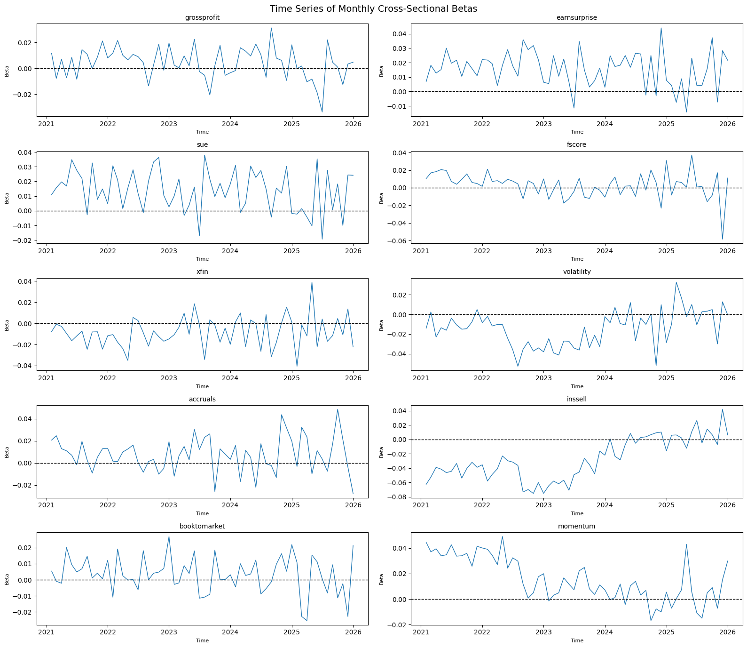
Figure 1 Time Series of Monthly Univariate Coefficients.
Other than f-score, all factors’ coefficients are statistically significant. The insider selling signal likely works because members of the c-suite typically sell their shares when they possess information indicating the price may fall. The momentum signal is likely significant because stocks that are doing well often continue to do well in a short-term horizon, and because investors generally underreact to good news of a stock’s performance over this period. The earnings surprise and SUE signals, which are quite related, likely work for a similar reason – because the market often underreacts to good news so prices will not immediately reflect a positive earnings announcement. The volatility signal is likely significant due to investors’ preference for lottery-like stocks leading them to overpay for more volatile stocks. The accruals and gross profitability signals likely work because of investor tendencies to focus on simple bottom-line metrics like EPS in an earnings report, causing them to neglect to consider signals that may signify either future growth (accruals) or efficiency at generating value from assets (gross profitability). The book-to-market signal likely is significant because investors tend to overextrapolate positive performance of low B/M (high price) firms, leading them to neglect high (B/M) firms. Finally, the external financing signal is likely significant because managers tend to raise capital when they believe the stock price is too high and will thus fall in the future.

Multivariate Analysis
All signals that were significant predictors of return in the univariate regressions remain significant predictors of return in the multivariate analysis. Moreover, f-score, the only insignificant factor in the univariate analysis, becomes significant in the multivariate tests.
Table 3 Average Monthly Multivariate Coefficients.
Factor | Average Beta | T-Statistic | Average R² | Average Number of Observations
Momentum | 0.0147 | 6.1364 | — | —
Earnings Surprise | 0.0114 | 5.9413 | — | —
Accruals | 0.0083 | 4.5543 | — | —
SUE | 0.0052 | 2.5663 | — | —
Gross Profitability | 0.0042 | 2.7846 | — | —
F-Score | 0.0038 | 2.1132 | — | —
Book-To-Market | 0.0032 | 2.4243 | — | —
External Financing | -0.0096 | -5.5561 | — | —
Volatility | -0.014 | -6.184 | — | —
Insider Selling | -0.0268 | -7.3305 | — | —
Model | — | — | 0.2252 | 200

The t-statistics and coefficients are nearly identical for volatility, insider selling, gross profitability, and B/M across the two analyses, indicating that these factors are robust independent indicators of returns. The t-statistics and betas for earnings surprise and SUE decrease notably in the multivariate case compared to the univariate tests, despite earnings surprise still being the second-largest positive coefficient in the multivariate setting. As SUE and earnings surprise are highly correlated, both measure how much recent earnings deviate from expected earnings, this decrease in coefficients and t-stats is unsurprising when both factors are controlled for within the same regression. The momentum t-statistic and coefficient also decrease, but more moderately than SUE and earnings surprise, in the multivariate case. The t-statistics and betas for both f-score and accruals increased in the multivariate tests, indicating the predictive power of these signals may only be uncovered when correlated signals are controlled for. The monthly coefficient estimates for the multivariate regression generally follow similar trends to the coefficients in the univariate regressions.
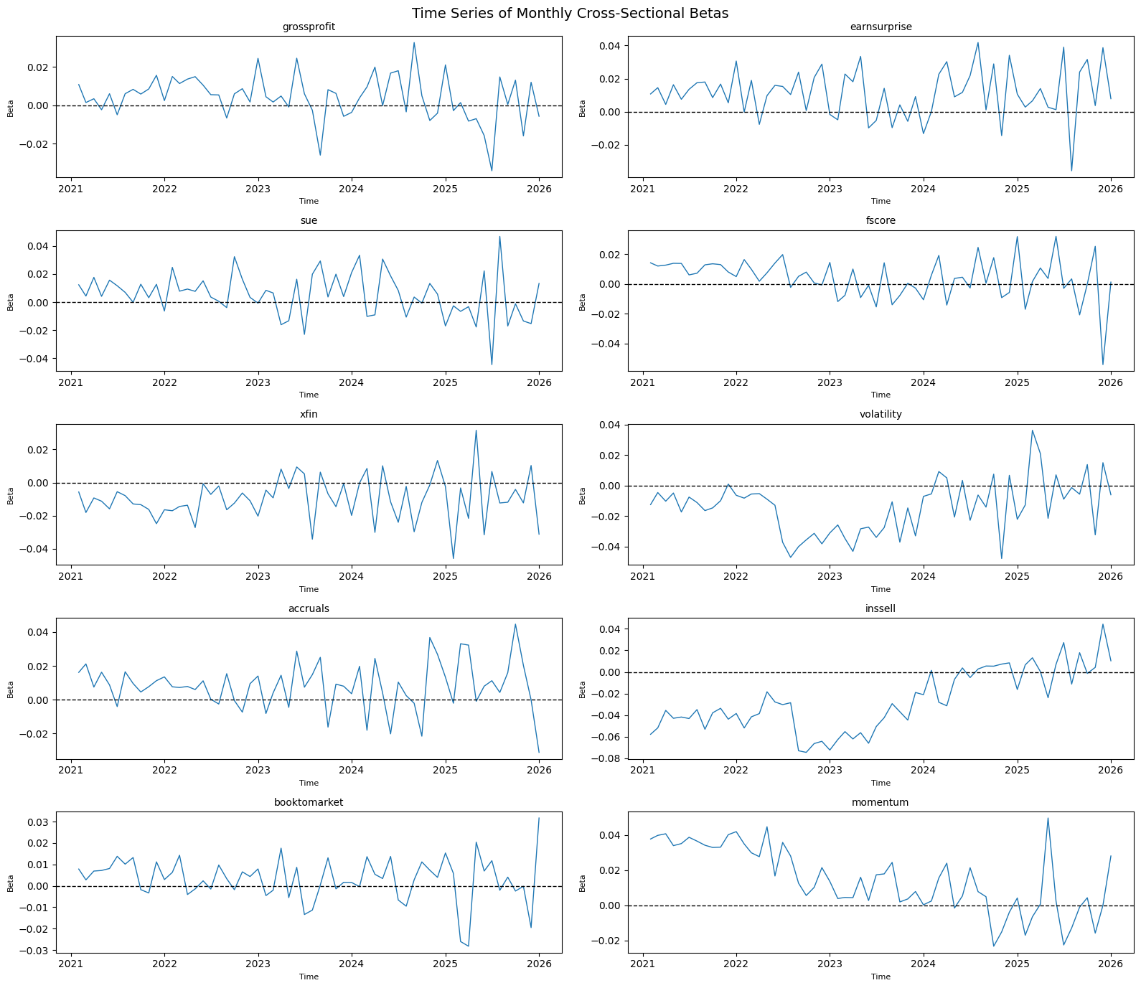
Figure 2 Time Series of Monthly Multivariate Coefficients.
The average R² of the model is 0.225. This value is more than double the highest R² from a single factor in the univariate tests, 0.1 for insider selling. Moreover, this value is more than an order of magnitude higher than many of the R² values for other univariate factors. This comparison shows that there is significantly more predictive power when the signals are combined in the multivariate model and that these tests can explain a non-trivial share of cross-sectional return variation.
All coefficients are from the multivariate regression and represent the predicted monthly return premium for a firm that is one standard deviation above the cross-sectional mean on a given signal relative to an average firm, holding all other signals constant: 1.5% higher returns (momentum), 1.1% higher returns (earnings surprise), 0.8% higher returns (accruals), 0.5% higher returns (SUE), 0.4% higher returns (gross profitability and f-score), 0.3% higher returns (book-to-market), 0.1% lower returns (external financing), 1.4% lower returns (volatility), 2.6% lower returns (insider selling).

Sharpe Ratio
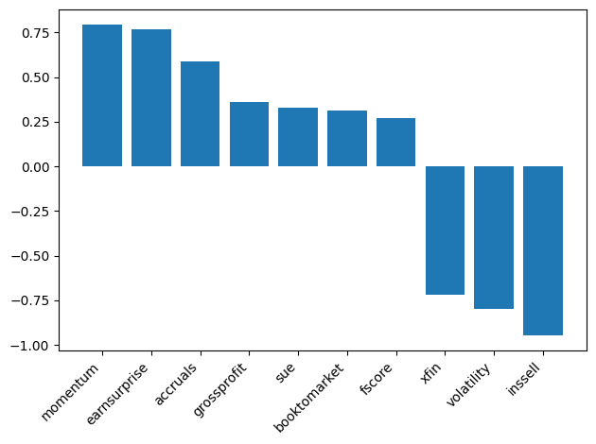
Figure 3 Sharpe Ratios of Monthly Multivariate Coefficients.
Of the 10 factors in the multivariate analysis, insider selling, volatility, momentum, and earnings surprise offer the strongest performance in terms of Sharpe ratio. As to be expected, momentum and earnings surprise have positive Sharpe ratios while insider selling and volatility have negative Sharpe ratios.
The implication from the absolute value of these Sharpe ratios is that the four factors listed above consistently predict returns each month more so than any of the other signals. This motivates the choice of an investment strategy of buying stocks with higher-than-average signals of momentum and earnings surprise, based on the positive Sharpe ratios, and shorting stocks with higher-than-average signals of insider selling and volatility, based on the negative Sharpe ratios. Since the Sharpe ratio reflects consistency of returns prediction, it naturally informs how these signals should be weighted when combined into a composite strategy, with each signal's independence ensuring that combination reduces reliance on any single predictor.

Signals were judged as statistically significant if their t-statistic exceed 1.645 in absolute value.

